**The CEO Report (12/4)**

**Preliminary Information:**

* This report contains additional information in regards to the previous report alongside analyses for the primary CEO focus.
* In this report, we began incorporating the analysis of mean squared error into our overall analysis. MSE is an estimator that measures the average of the squares of the errors. It is a risk function corresponding to the expected value of the squared error loss. It is a measure of the quality of an estimator that is always non-negative where values closer to zero are more preferable.

**Trend Analysis for CEO Age Estimation Error in Years (Chart 1)**

|  |  |  |
| --- | --- | --- |
|  | **Amazon** | **Microsoft** |
| **Sample Size** | 309 | 461 |
| **Average Error** | -3.80 | -2.26 |
| **Standard Error** | 9.75416 | 6.80377 |
| **R-Squared** | 0.233595 | 0.29204 |
| **Mean Squared Error\*** | 49.91 | 36.38 |
| **Mean Squared Error\*\*** | 107.81 | 56.54 |

* = Sum of (Apparent Age - Real Age)^2 / Size of Total Set.

** = Sum of (Apparent Age - Apparent Age Set Average)^2 / Size of Total Set.

**See Fig. 1 for plot.**

**Trend Analysis for MSEs of Obama Age Estimation in Years Paired Against Actual Age (Chart 3)**

|  |  |  |  |  |
| --- | --- | --- | --- | --- |
|  | **AM MSE\*** | **AM MSE\*\*** | **MS MSE\*** | **MS MSE\*\*** |
| **Sample Size** | 30 | 30 | 30 | 30 |
| **Average** | 115.1 | 82.0 | 51.4 | 41.3 |
| **Median** | 105.0 | 63.5 | 38.8 | 35.0 |
| **Standard Error** | 52.8 | 44.9 | 13.5 | 44.4 |

* = Sum of (Apparent Age - Real Age)^2 / Size of Total Set.

** = Sum of (Apparent Age - Apparent Age Day Average)^2 / Size of Total Set.

**Fig. 1**

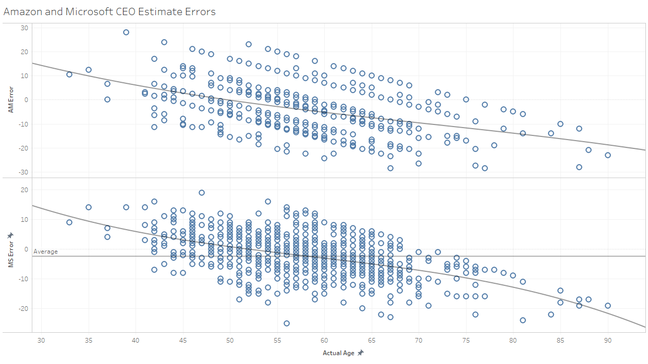

**Fig. 2**

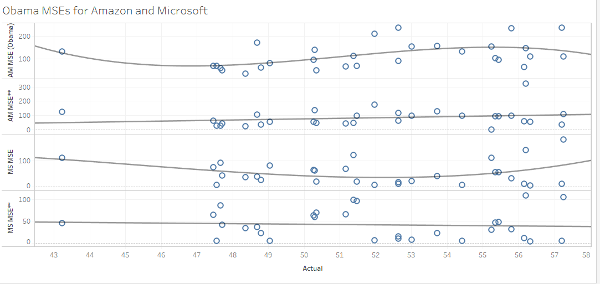

First and third charts are MSE*, second and fourth are MSE**, all had R-squared values < 0.25.

**Fig. 3**

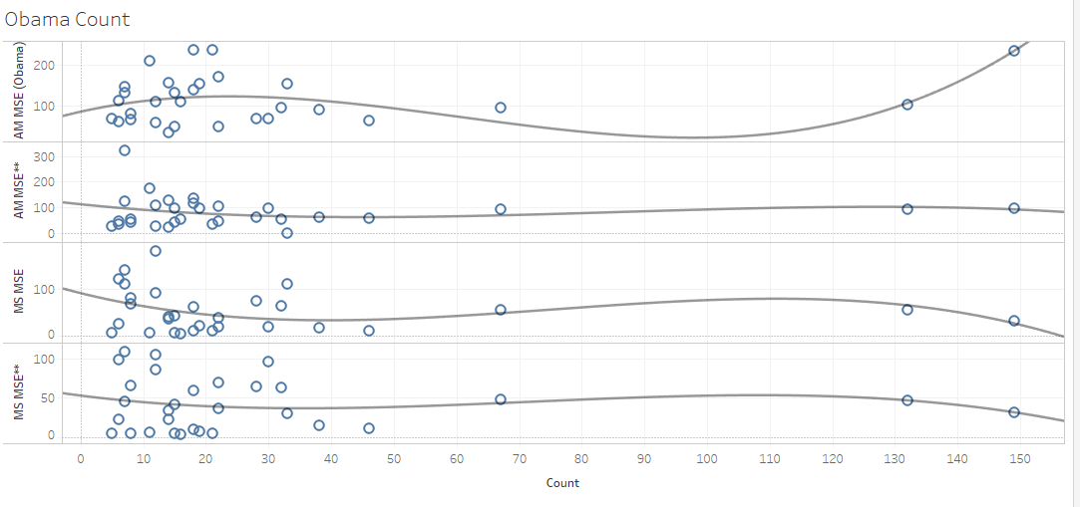

First and third charts are MSE*, second and fourth are MSE**.

No trend line had an R-squared value higher than 0.18, with three being under 0.1.

**Fig. 4**

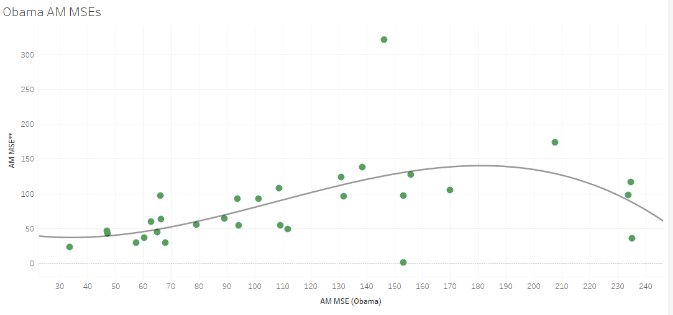

R-squared of the trend line is 0.314.

**Fig. 5**

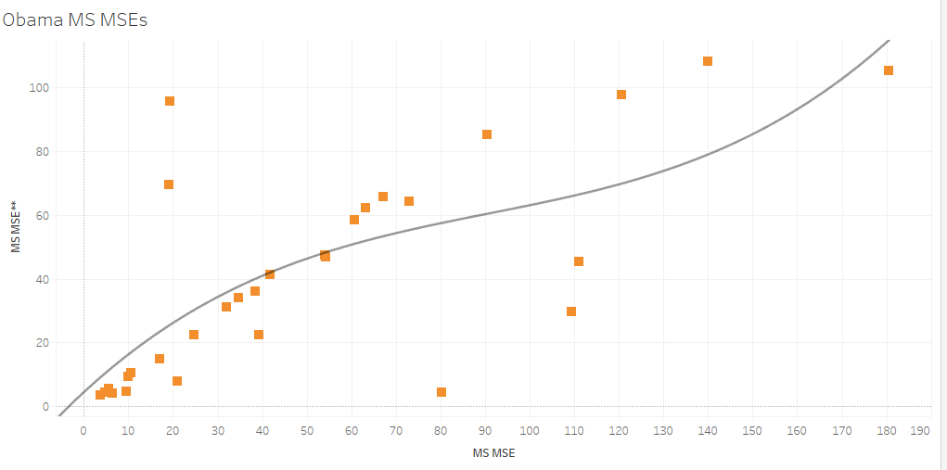

R-squared of the trend line is 0.524.

**Fig. 6**

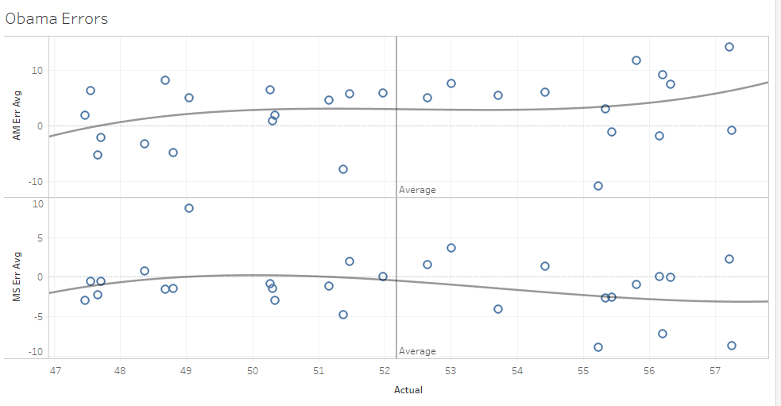

This chart shows the daily average error for each set of data that was collected for Obama.

**Analysis:**

* Of the four different MSEs calculated for the thirty points of Obama data, only the MSE in regards to Amazon error between actual age and estimation produced slightly significant R-squared values when paired against actual age and count, while none of the other MSEs produced significant values for either. The respective values (0.265 and 0.189) were both weak, and as such, may not be indicative of a real correlation due to Amazon’s tendency to use a handful of ‘generic’ estimations as opposed to a unique estimation for each image. As such, we believe these two values should be lower, and thus, there is no correlation between any of the four MSEs calculated for each set and either actual age or count. **(See Fig. 2 and 3)**
* In regards to MSE* for Obama, both Microsoft’s average and median were notably smaller than that of Amazon’s, with the average being only half of Amazon’s and the median being a third of Amazon’s. This is arguably are most notable evidence towards Microsoft giving estimates that are consistently closer to the actual age of the person in the photo. **(See Chart 3)**
* In regards to MSE** for Obama, both Microsoft’s average and median were nearly half that of Amazon’s. Hence, we believe this shows that Microsoft is better at converging upon a particular age for photo sets from a particular day as opposed to Amazon.

**(See Chart 3)**

* When CEO estimation error for both Amazon and Microsoft were plotted against actual age, **Fig. 1** showed a very clear trend in error that decreased with age. At its highest end with multiple points, Amazon’s highest errors were between ages 43 and 46 that were around an error of 20 at highest and -10 at lowest. Microsoft peaked as well between ages 43 and 46 with its highest errors being around 15 and its lowest around -5. At ages 75 to 85, Amazon’s highest errors were around 0 and its lowest around -28. Microsoft’s highest errors for the same age range were around -7 and its lowest around -20. We believe this shows that CEOs age at a much higher rate earlier in life such that they appear notably older, then remain at the same state of that advanced aging physically such that they appear that same certain age for a notable margin of time.
* **(*)** According to **Fig. 1**, both Amazon and Microsoft showed that CEOs begin to appear their actual age on average at 57, at earliest 42, and at latest, 72. This supports are previous notion that CEOs may physically age faster than average in a matter of year earlier in life, and then physically remain looking that certain age for a notable margin of time.
* While both softwares returned a negative average error, we do not believe that this should be interpreted in such a way that CEOs of all ages should, on average, be assumed to look roughly three years younger than they actually are. Rather, we believe that this value indicates that CEOs on average continue to work for a longer period of time after reaching the age in which they appear their actual age than the period of time as CEO beforehand.
* Due to a large enough sample size with enough variation in actual age alongside gained familiarity with Tableau, we’ve noted that Amazon’s ‘generic’ age estimations are 43.5, 48.5, 55, 58, 67, and 75.
* When Obama’s daily error vs. actual age chart, **Fig. 6**, is analyzed in the context of Analysis **(*)**, it can be seen that Obama’s aging follows a trend *somewhat similar* to that of the CEO trend, but not exactly the same. In the AM chart, it can be seen that Obama goes from appearing younger than he actually is to older, peaking at age with with an error of ~3, remains with the same physical appearance until 55, and then begins looking even older.

In the MS chart, it can be seen that obama goes from appearing younger than he actually is to appearing his actual age at 50, and then begins appearing younger than he actually looks again at 52, which finally plateaus with him reaching ~3 years younger than he actually is at 57.

**Trend Analysis for Random 15 CEO Age (Chart 4)**

(In this dataset, the number of photos per CEO is greater than 5)

|  |  |  |
| --- | --- | --- |
|  | **Amazon** | **Microsoft** |
| **Sample Size** | 372 | 380 |
| **Average Error** | -0.57 | -0.70 |
| **Standard Error** | 10.16 | 7.115 |
| **R-Squared** | 0.0856 | 0.127 |
| **Mean Squared Error\*** | 112.56 | 58.18 |
| **Mean Squared Error\*\*** | 106.78 | 64.20 |

* = Sum of (Apparent Age - Real Age)^2 / Size of Total Set.

** = Sum of (Apparent Age - Apparent Age Day Average)^2 / Size of Total Set.

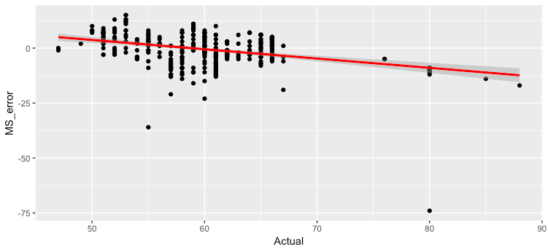

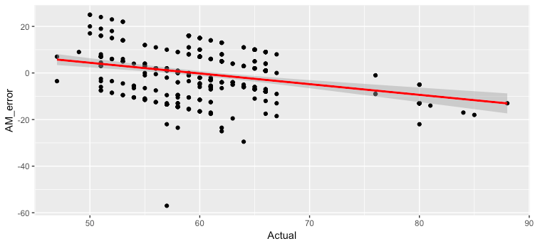

* Comparing to MSE** in Chart 1, the MSE** in Chart 4 is smaller. This means that the predicted ages deviate a smaller amount from the average. However, the MSE* and MSE** are very close in value in Chart 4, which shows that feeding in more than 5 photos per CEO gives us relatively stable predictions.
* Feeding in more than 2 photos of the same person does not give us a very accurate prediction, as each photo age prediction has a greater deviation from its true value: this is shown by the larger MSE* comparing to that in Chart 1. However, as more photos are fed in, they tend to cancel each other out, leaving us with a smaller Average Error, which means the prediction tends to deviate by similar amount in both positive and negative directions.
* Both AM and MS overestimates the age of CEOs before 60 (the CEOs look older than their actual age), and underestimate their age after 60 (the CEOs look younger than their actual age).

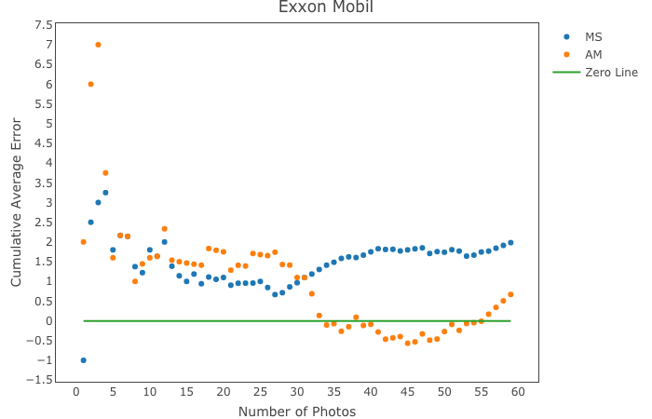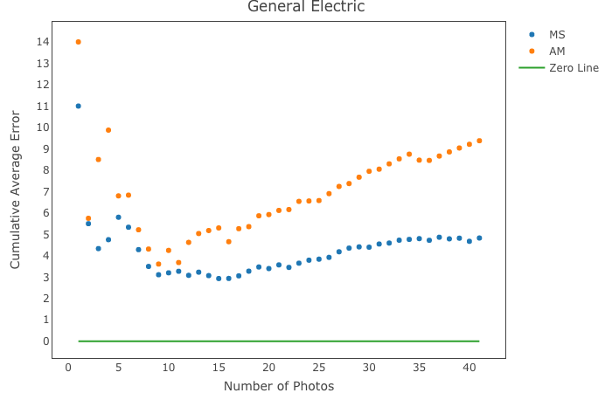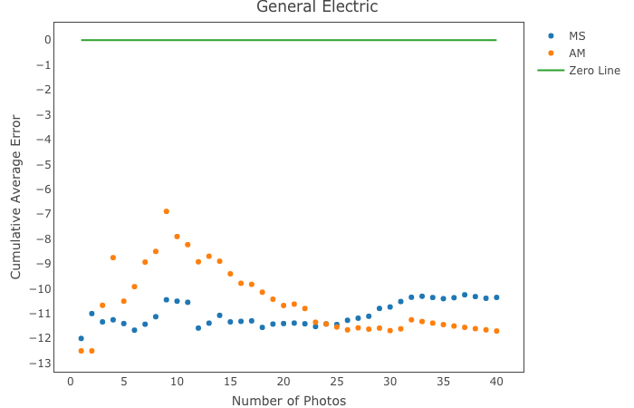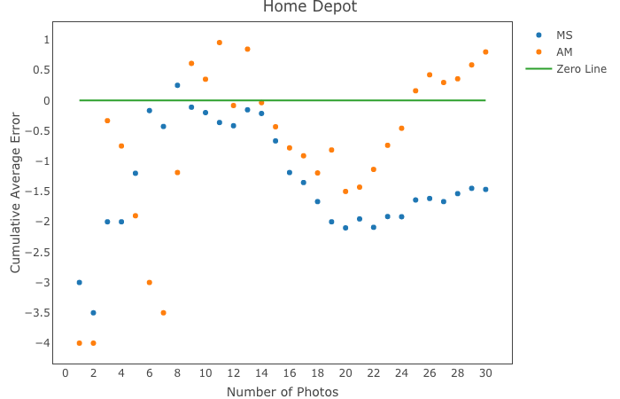

* From graphs plotted above of Number of photos fed in against the cumulative average error, we can see that a prediction closest to the average age is usually reached at around 10-15 photos for both Microsoft and Amazon.